Documentary of Humms Project

Made by:

Del Socorro, Marc Dave A.

Submitted to:

Mrs. Jofe Marie Garvez

Week 1

Ornamental Plants:

Rose Gummamela

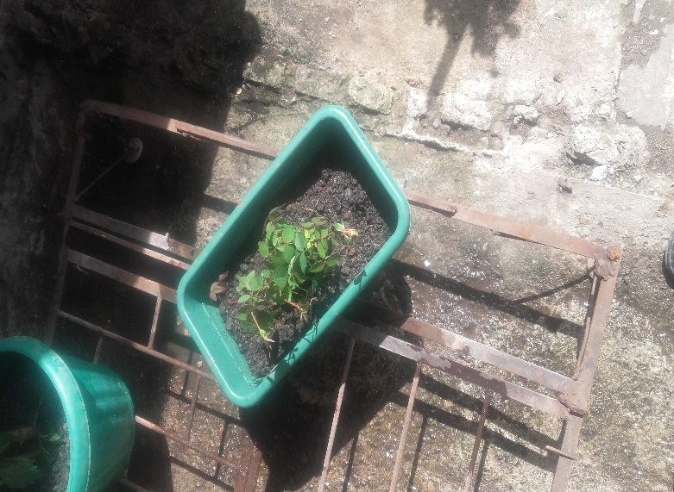

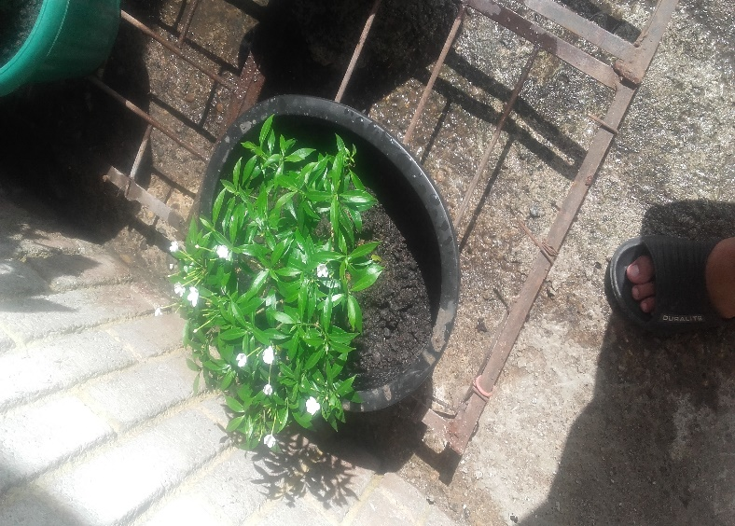

Herbal Plants:

None

Spices:

Onion Leaves

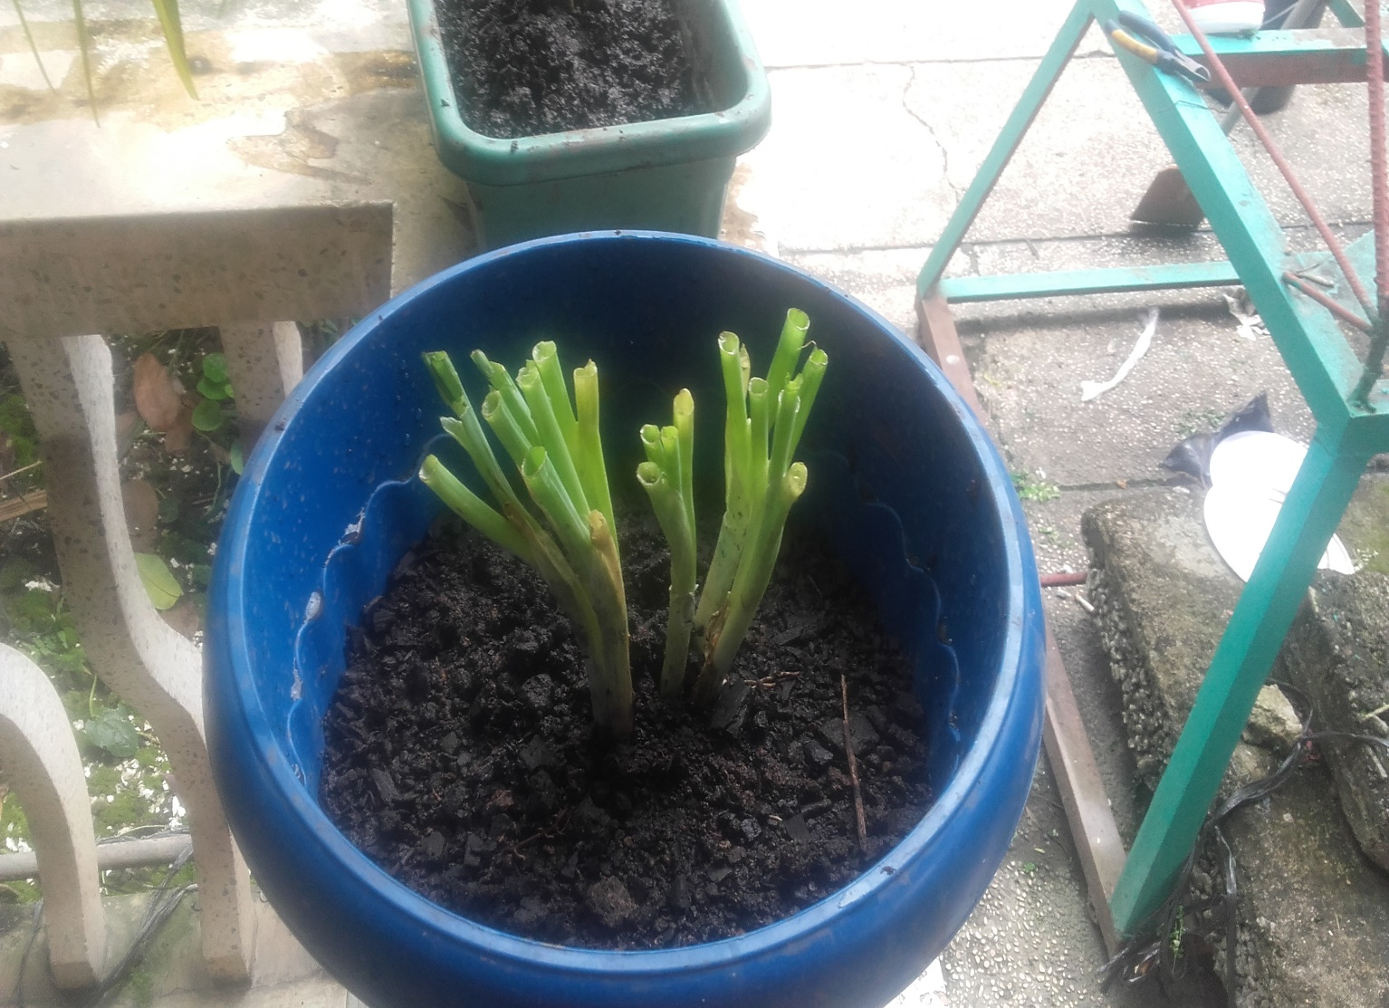

WEEK 2

Ornamental Plants:

Rose Gummamela

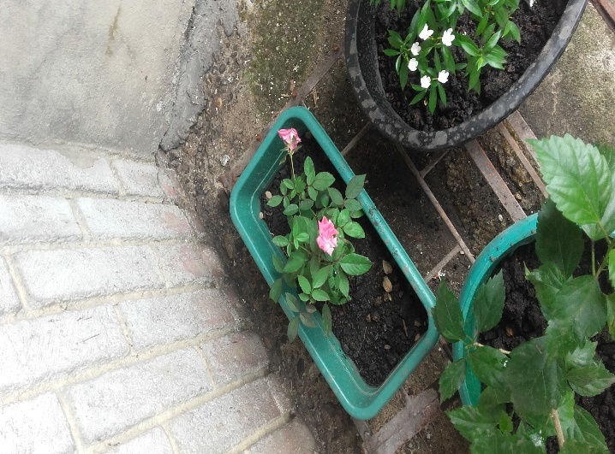

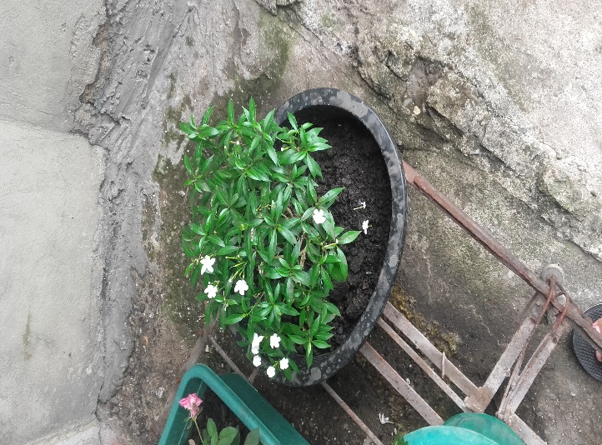

Herbal Plants:

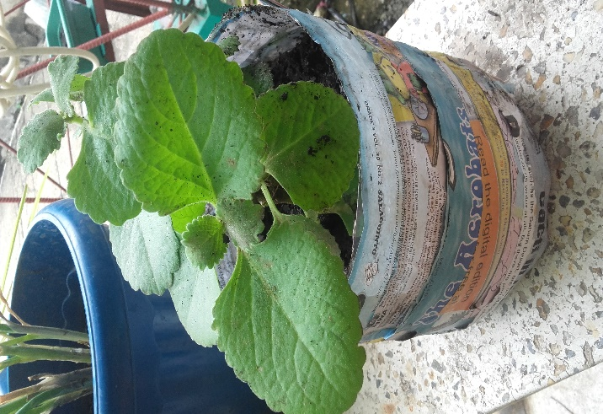Calabo Lemon Grass

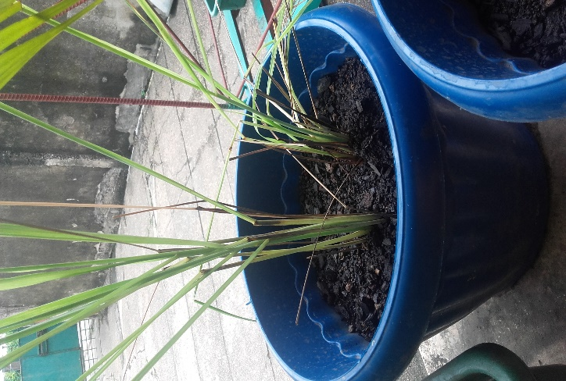

Spices:

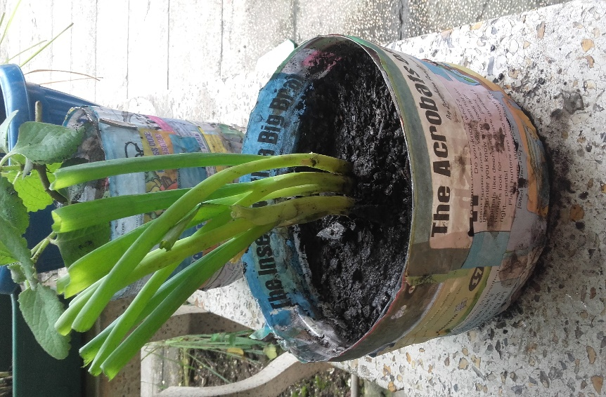Onion Leaves

Week 3

Ornamental Plants:

Gummamela Rose

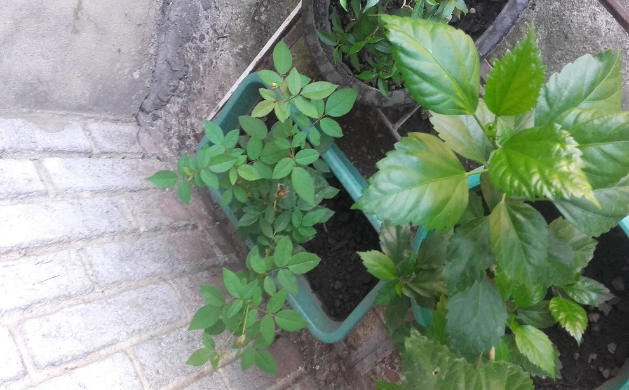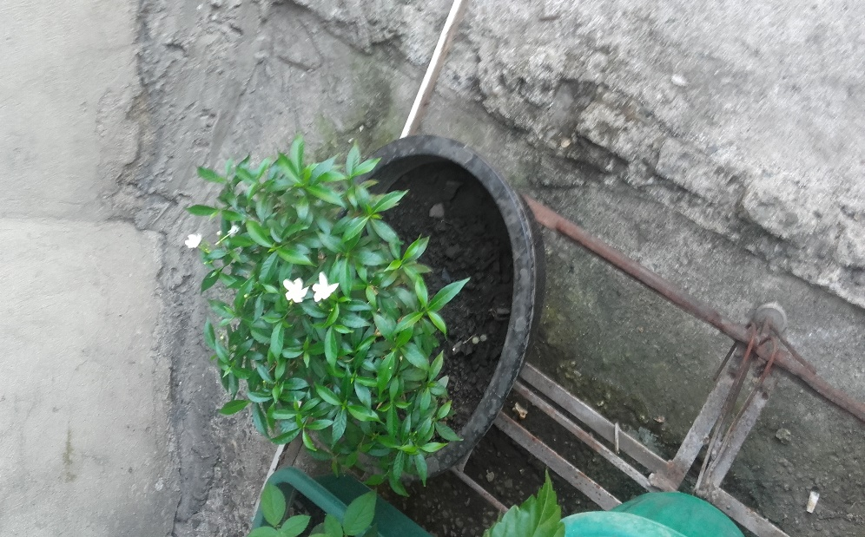

Herbal Plants:

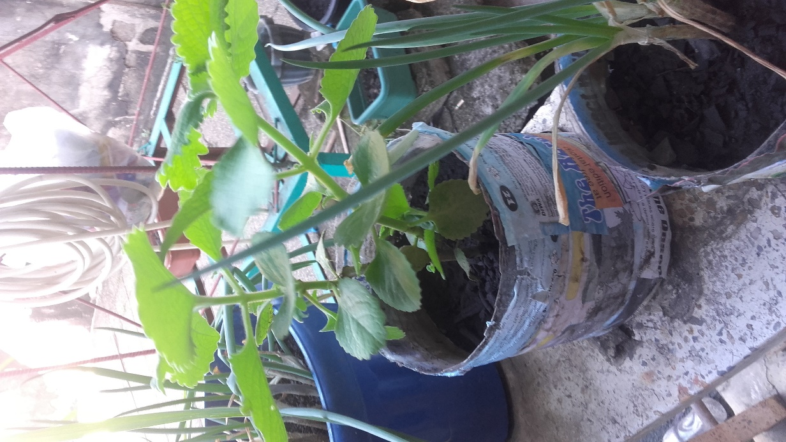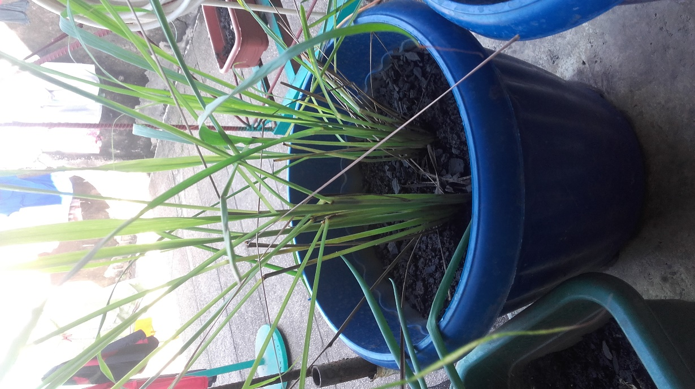Lemon Grass Calabo

Spices:

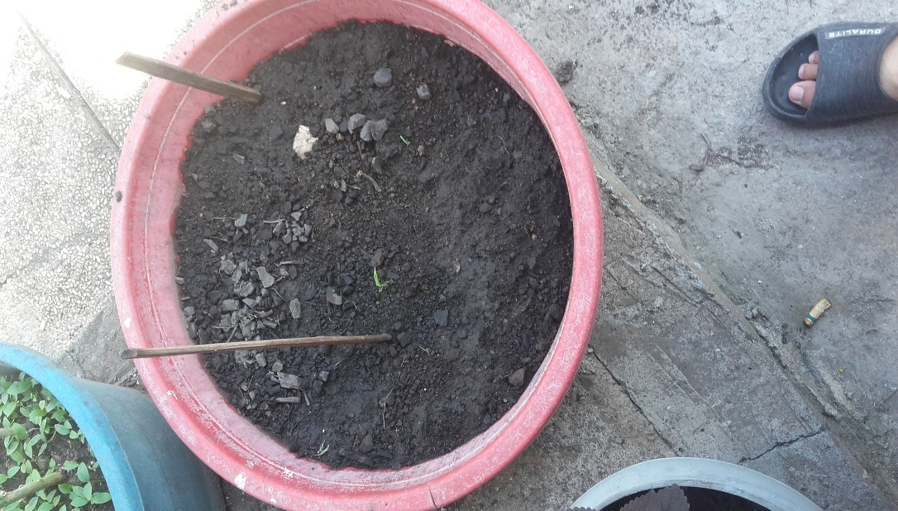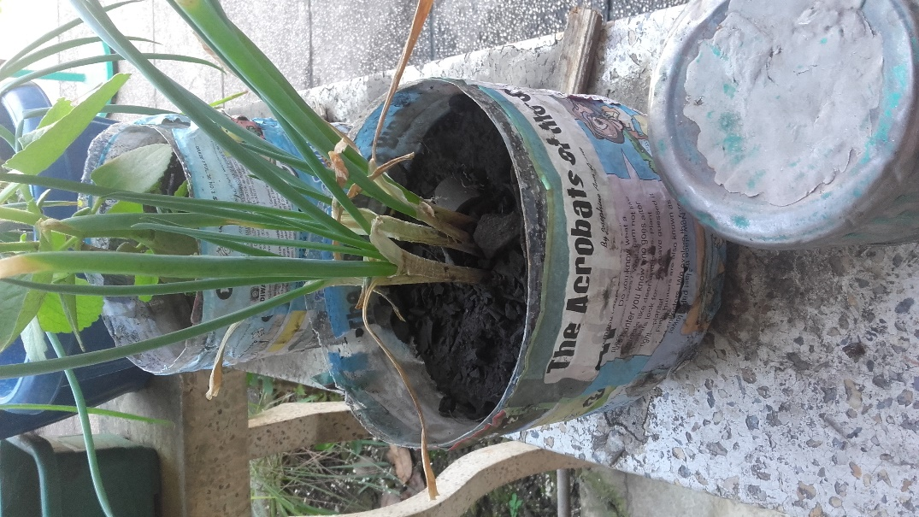Onion Leaves Ginger

Week 4

Ornamental Plants:

Gumamela Rose

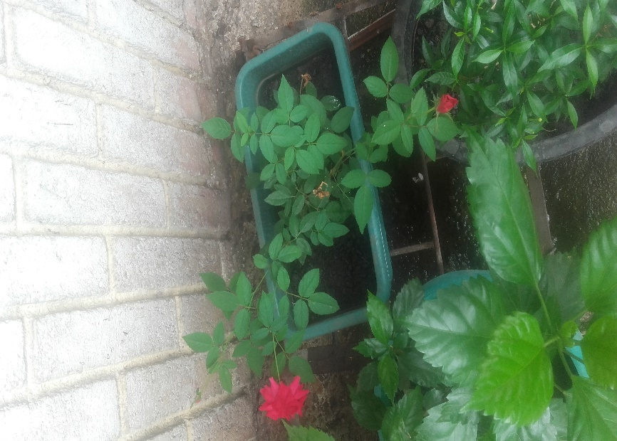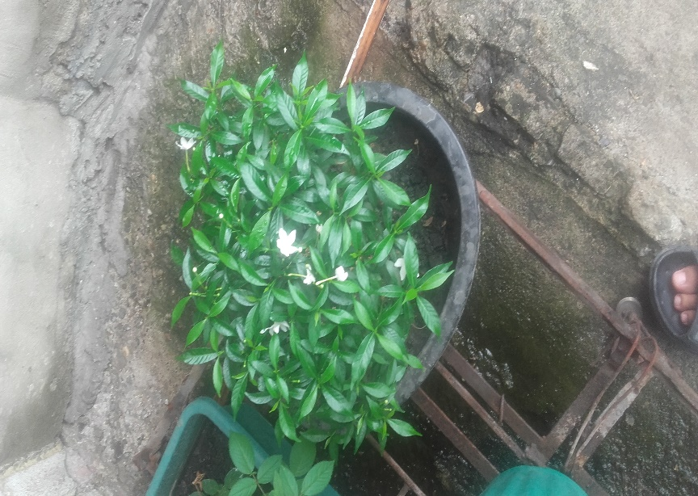

Herbal Plants:

Lemon Grass Calabo

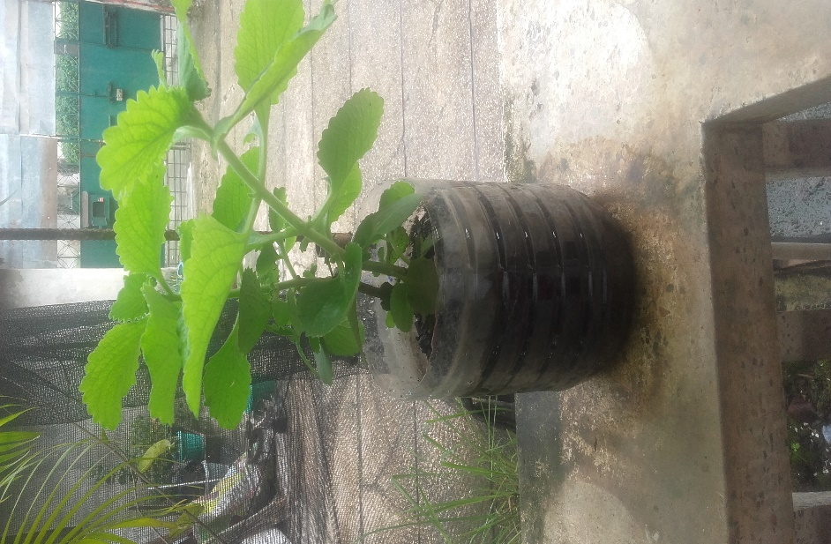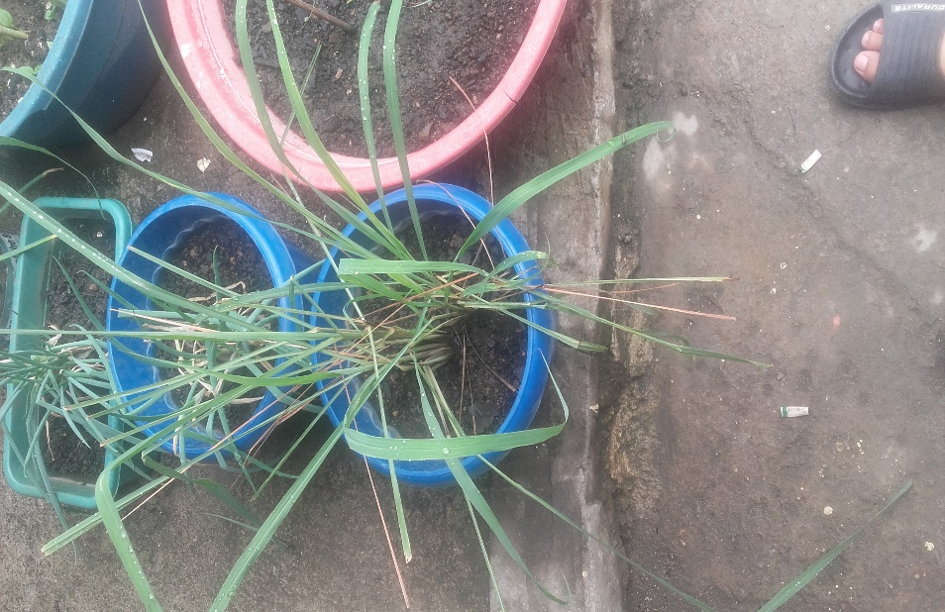

Spices:

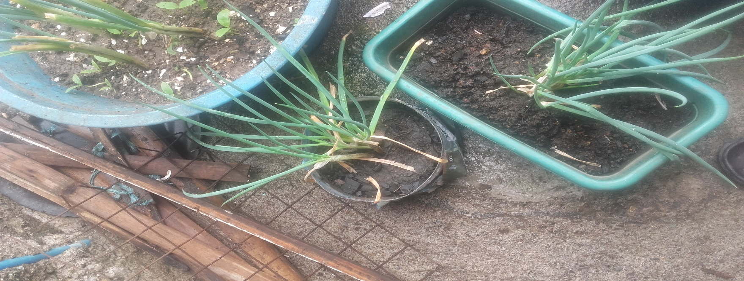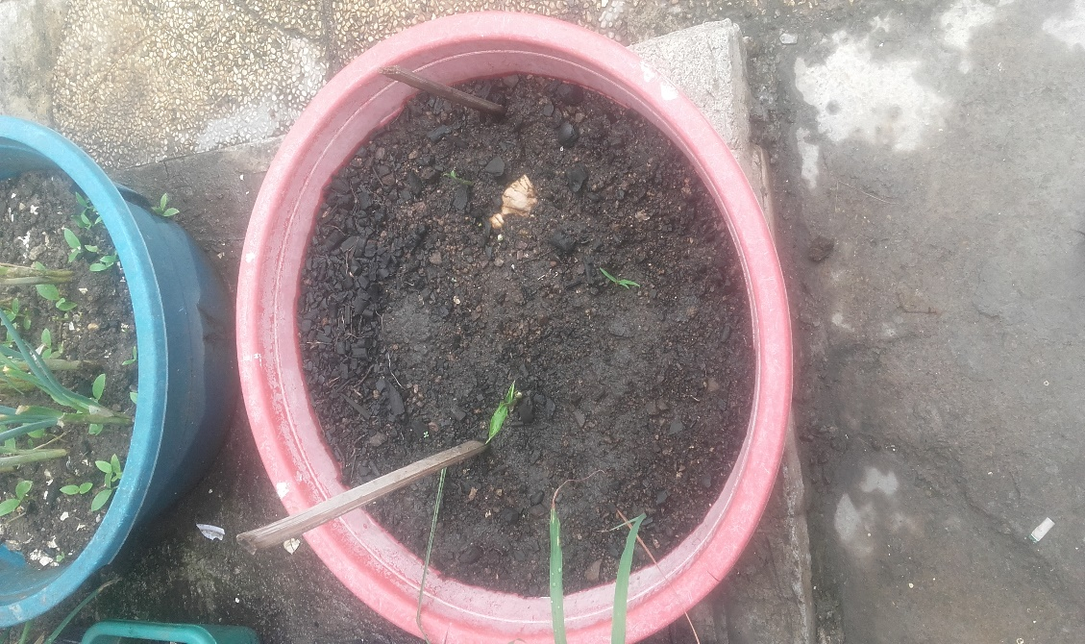Ginger Onion Leaves

Week 5

Ornamental Plants:

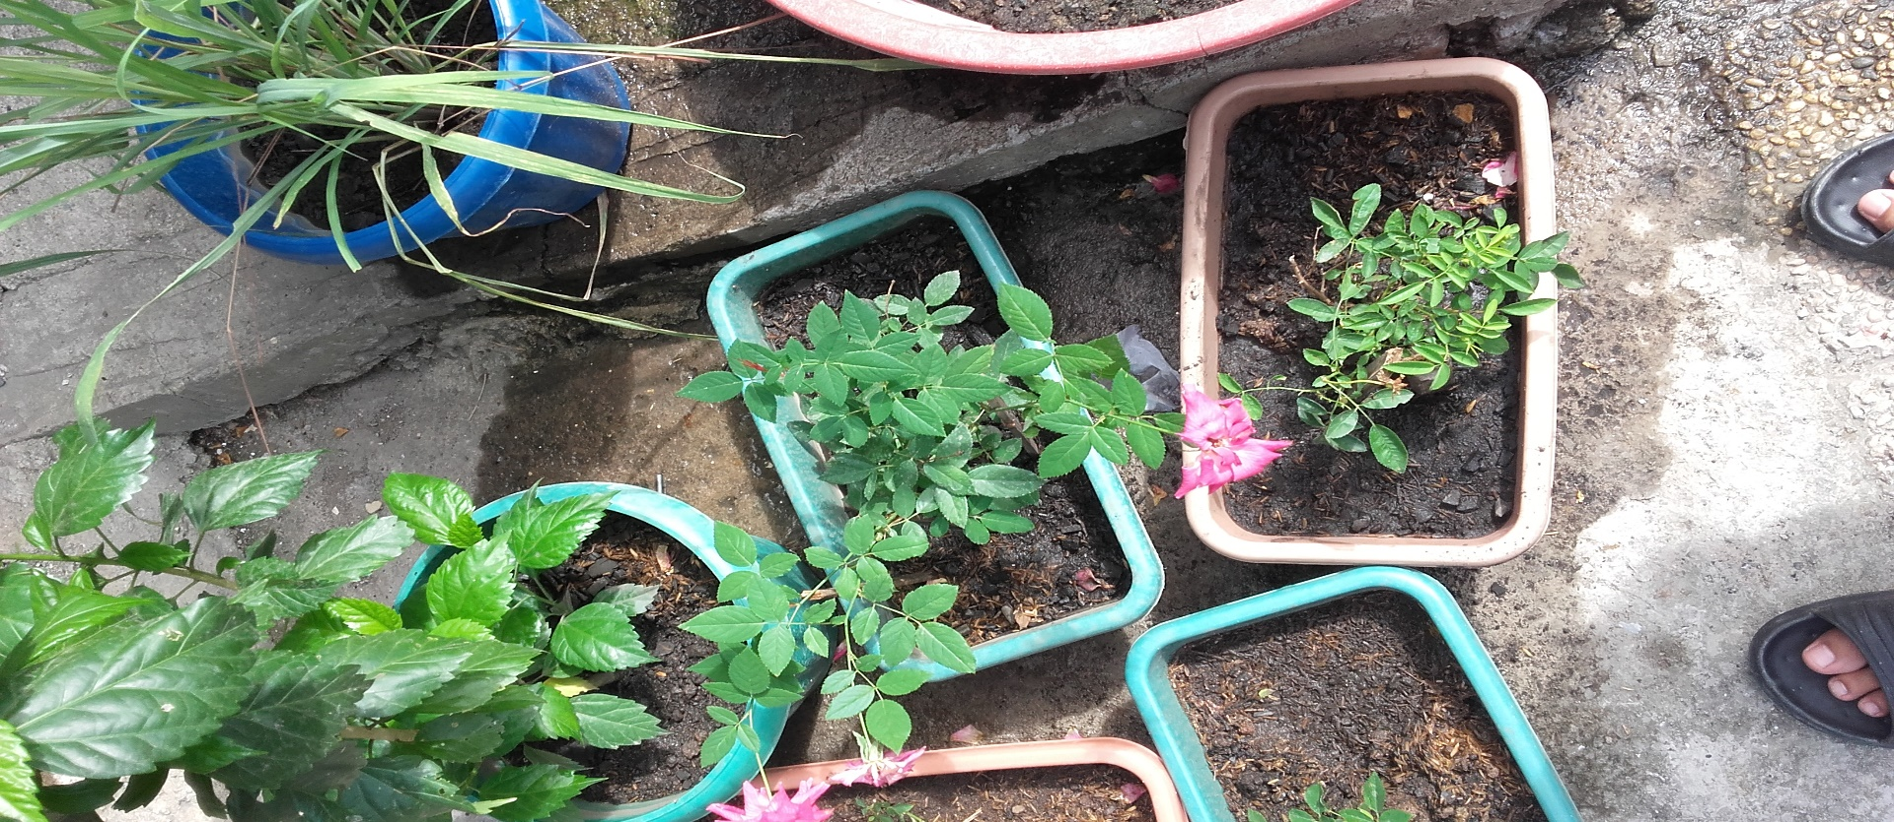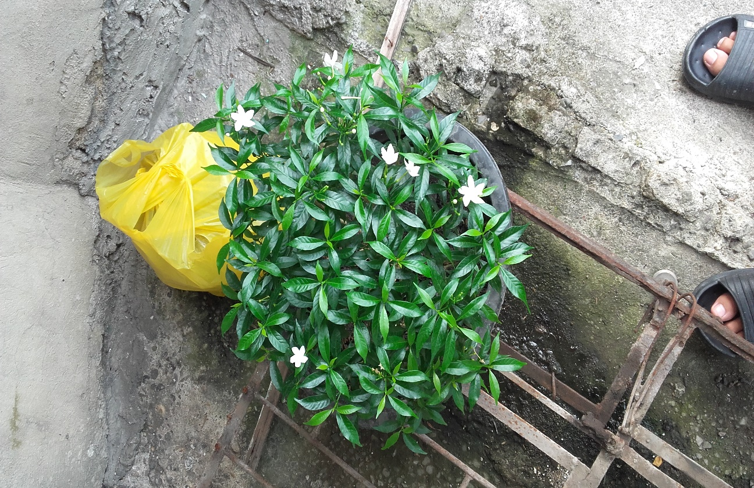Gumamela Rose

Herbal Plants:

Lemon Grass Calabo

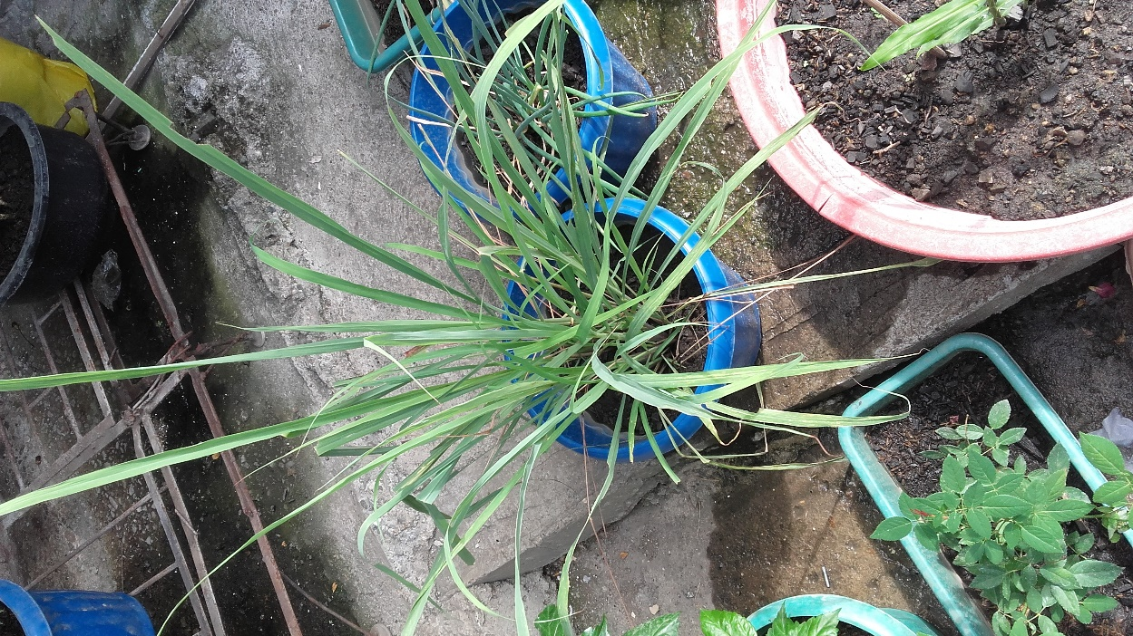

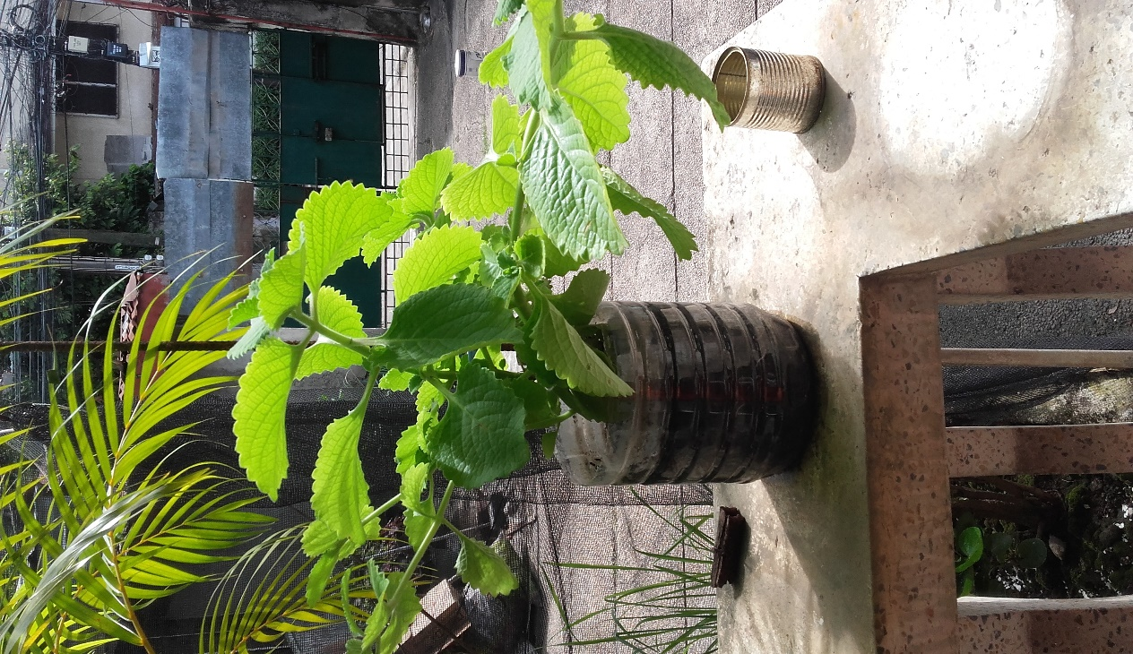

Spices:

Ginger Onion Leaves

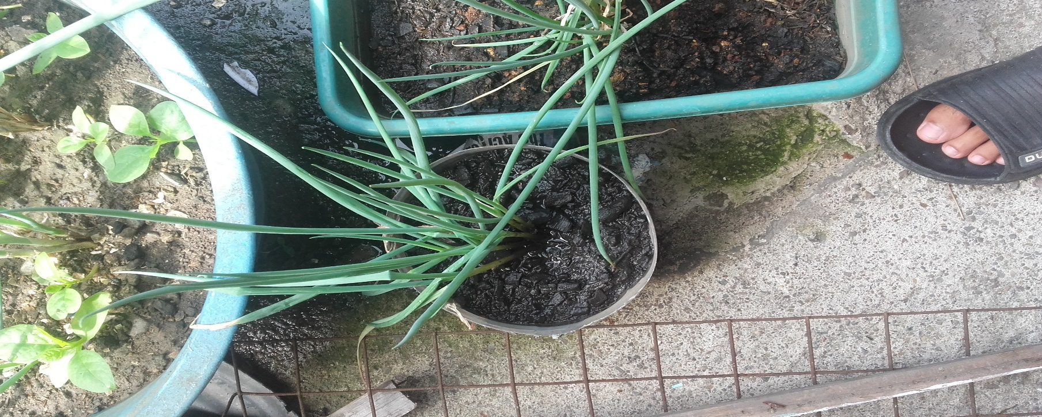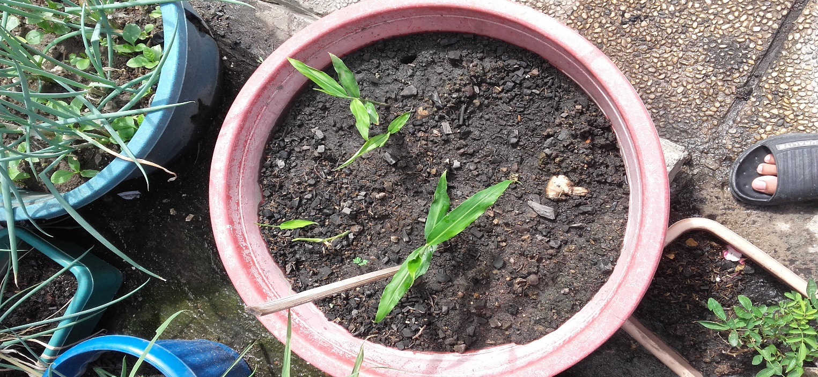

Common usage each plants:

Calabo – Used for cough remedies by dissolving or mixing it with water.

Ginger – Used as spices in the kitchen.

Onion Leaves – Used for spices in the kitchen.

Lemon Grass - The leaves and the oil are used to make medicine.

Roses – Design/s.

Gumamela – Design/s.

What I’ve learned from such activity:

Plants absorb or breathe in carbon dioxide which is one of the gases that emit the greenhouse effect in our world which causes our world or even just our surrounding/s to heat up which is one of the reasons why my house or my surrounding/s right now feels a lot cooler than what is was back then.